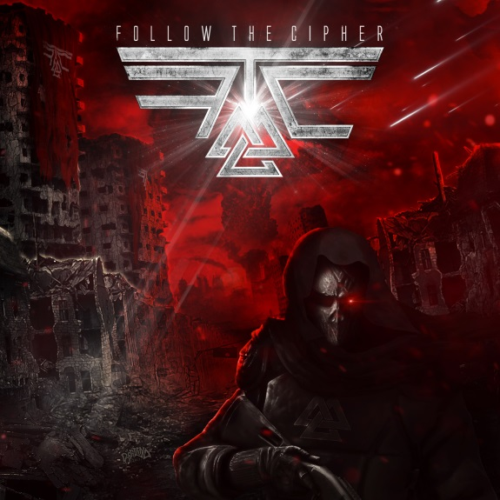

FOLLOW THE CIPHER
»Follow The Cipher«

OUT: May 11th, 2018

Line-up: | FOLLOW THE CIPHER online:
Linda Toni Grahn | lead vocals  Ken Kängström | guitars & vocals  Viktor Carlsson | guitar & vocals  Jonas Asplind | bass & vocals  Karl Löfgren| drums | www.followthecipher.com  www.facebook.com/followthecipher  www.nuclearblast.de/followthecipher

Creativity’s Capital Falun
Falun – this magical city in the heart of Sweden, surrounded by idyllic forests and deep blue lakes, emerges more and more as a creative center for ambitious and talented young bands. Is it in the water? Is it in the air? No one knows, but it remains a fact that Falun is the glorious birthplace of some of the most promising and hottest acts on this planet. After spawning bands like SABATON, TWILIGHT FORCE, CIVIL WAR and BILLION DOLLAR BABIES, Falun now has a new up-and-coming crew in stock. Forget everything you thought you knew, because FOLLOW THE CIPHER are ready to herald in a new musical era and crash through the many dimensions of our universe to steal your breath. Despite their stylistic diversity, the Swedish metal act creates a very cohesive ambience, mixing a first class sound with magical charisma, an innovative concept, live presence and an incredibly talented singer.

Starting point: SABATON
Let's take a little look into the past: FOLLOW THE CIPHER’s story started in May 2014, when Ken Kängström decided to start a band with the intention to be different from everything else in the music scene. The idea itself had been haunting his mind for years, but the catalyst to finally put his thoughts into action was the result of a longtime collaboration with the internationally acclaimed metal giants SABATON, with whom FOLLOW THE CIPHER maintain a close friendship. Ken Kängström is definitely not a newcomer in the Scandinavian music scene, since he co-wrote and co-produced some well-known SABATON songs with Joakim Brodén, such as the monumental anthem ‘Carolus Rex’. It was this track which got the ball rolling for Ken: "I think the song sparked the first inspiration in me – in particular, it was responsible for me starting to trust my own abilities and judgment," Ken reflects. "When me and Joakim wrote this track, I felt deep inside that it was time to put my plans with FOLLOW THE CIPHER into action." Therefore, the band has also included a version of this important track, ‘Carolus Rex’, on their debut album.

Breaking boundaries
Eventually, Ken composed new pieces with the premise of copying nothing and nobody, creating a completely unique sound cosmos filled with epic melodies, bombast, razor-sharp riffs and electronic vibes. The band’s diversity ranges from symphonic moments to a sinister post-apocalyptic, modern atmosphere. "At a certain point I started to understand that the most important aspect in regards to creating great songs is to keep a constant balance – not just for the individual elements in the music, but also for the overall sound mixture," the Swede explains. "From that moment on, I was able to control the sound and could start with the essential evolution of FOLLOW THE CIPHER. Later on Viktor Carlsson joined the band as a second songwriter to write half the album and then the sound was complete.”

Something unique was born, growing to become a mixture between NIGHTWISH, IN FLAMES and SABATON, yet creating something completely different and innovative. "I consider our music as both visual and cinematic," says Ken. "The sound is large-scaled and multi-layered - each element plays an important role within the overall concept. You can listen to our music in two different ways; either by focusing on the individual, versatile elements like the keyboard melodies or Linda's powerful voice, or you can indulge in the whole package. Both type of listeners will get what they look for in our very own CIPHER METAL!“ Ken states euphorically, while Viktor Carlsson goes even further: "The process of creativity cannot be put into words. Sometimes it feels as if all the creativity is flowing by itself, and sometimes you just don’t know how to continue your work and feel completely lost. But one way or the other, it is always magical - especially since all of us have different musical backgrounds. This is certainly the main reason for all the artistic versatility on the record. Each one of us has brought in their individual style and overcome their own hurdles – through this collaboration we all grew to become better musicians.”

Welcome on board
The CIPHER crew consists of five talented members; Linda Toni Grahn, a fantastic and highly talented singer, with long pinkish red hair and emerald eyes, equipped not only with a powerful and characteristic voice, but also outstanding charisma. When taking to the stage, all it takes are a few seconds for Linda to capture everyone’s attention. "Linda is unique - she stands out from the crowd, not only as a great singer, but also as a charismatic personality! Immediately after meeting her, I knew she would be the right person for us!” Ken Kängström (guitar) recalls the first meeting with their female captain of the CIPHER workforce. Other crew members include Karl Löfgren (drums), Viktor Carlsson (guitar) and Jonas Asplind (bass).

Audio visual apocalypse
FOLLOW THE CIPHER is an ambitious troop, not only do they express their passion through their music, but also through their extravagant outfits and impressive live shows.
Therefore it didn’t come as surprise, that the world’s biggest metal label, Nuclear Blast, signed them after experiencing the band live at Sabaton Open Air 2017. "We had them on our radar for the past two years, were convinced of the song quality and appreciated the commitment of the members. Eventually, the determining factor was their outstanding live performance, which proved to us that FOLLOW THE CIPHER have everything they need," states Markus Wosgien, A&R of the German metal label. Astoundingly, this was only the second ever (!) live performance by the five musicians (the first took place at the legendary "Masters Of Rock" in Czech Republic and was no less spectacular!). Next year, the Swedes will invade Belgium’s "Graspop" festival and stage a very special audio visual performance with an apocalyptic, Mad Max style feel to it

FOLLOW THE CIPHER are already enjoying a strong fan base among other musicians and for their grandiose anthem ‘Starlight’ they gathered several star guests from the Swedish metal elite, such as Joakim Brodén (SABATON), Nils Patrik Johansson (ASTRAL DOORS), Johnny Lindkvist (NOCTURNAL RITES) and Ronny Hemlin (TAD MOROSE).

To cut a long story short, the CIPHER crew is more than ready to take you on an exciting journey through the darkest galaxies of metal. Are you ready to join them? It's time to open a new chapter of heavy metal history – it's time to FOLLOW THE CIPHER!

CD Tracklist:

01. Enter The Cipher 02. Valkyria 03. My Soldier 04. Winterfall 05. Titan’s Call 06. The Rising
07. A Mind’s Escape 08. Play With Fire 09. I Revive 10. Starlight 11. Carolus Rex

